- Basic definitions
$$\sin\left(α\right)=\frac{a}{c}$$
cos(α) = b/c
tan(α) = a/b

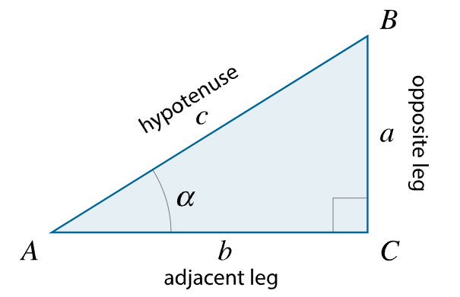
- Basic Identities
$$\sin\left(x\right)= \frac{1}{\csc\left(x\right)}$$ | $$\csc\left(x\right)= \frac{1}{sin⁡(x)}$$ | $$\tan\left(x\right)= \frac{sin⁡(x)}{cos⁡(x)}$$
$$\cos\left(x\right)= \frac{1}{\sec\left(x\right)}$$ | $$\sec\left(x\right)= \frac{1}{cos⁡(x)}$$ | $$\cot\left(x\right)= \frac{cos⁡(x)}{sin⁡(x)}$$
$$\tan\left(x\right)= \frac{1}{cot⁡(x)}$$ | $$\cot\left(x\right)= \frac{1}{tan⁡(x)}$$

- Pythagorean Identities

$$\sin^{2}\left(x\right)+ \cos^{2}\left(x\right)=1$$ | $$\sin^{2}\left(x\right)=1- \cos^{2}\left(x\right)$$ | $$\cos^{2}\left(x\right)=1- \sin^{2}\left(x\right)$$
$$\csc^{2}\left(x\right)- \cot^{2}\left(x\right)=1$$ | $$\csc^{2}\left(x\right)=1+\cot^{2}\left(x\right)$$ | $$\cot^{2}\left(x\right)= \csc^{2}\left(x\right)-1$$
$$\sec^{2}\left(x\right)- \tan^{2}\left(x\right)=1$$ | $$\sec^{2}\left(x\right)={1+tan}^{2}\left(x\right)$$ | $$\tan^{2}\left(x\right)= \sec^{2}\left(x\right)-1$$

- Sum and Difference Identities
$\sin\left(x±y\right)=\sin\left(x\right)\cos\left(y\right)±\cos\left(x\right)\sin\left(y\right)$
$$\tan\left(x±y\right)= \frac{\tan\left(x\right)±tan⁡(y)}{1∓\tan\left(x\right)tan⁡(y)}$$
$$\cos\left(x±y\right)=\cos\left(x\right)\cos\left(y\right)∓\sin\left(x\right)\sin\left(y\right)$$
- Cofunction Identities
$$\sin\left(\frac{π}{2}-x\right)=\cos\left(x\right) \cos\left(\frac{π}{2}-x\right)=sin\left(x\right) sin\left(x±\frac{π}{2}\right)= ±\cos\left(x\right) \cos\left(x± \frac{π}{2}\right)= ∓sin⁡(x)$$
$$\tan\left(\frac{π}{2}-x\right)=\cot\left(x\right) \cot\left(\frac{π}{2}-x\right)=tan⁡(x)$$
$$\sec\left(\frac{π}{2}-x\right)=\csc\left(x\right) \csc\left(\frac{π}{2}-x\right)=\sec\left(x\right)$$
- Double Angle Identities
$$\sin\left(2x\right)=2\sin\left(x\right)\cos\left(x\right) \cos\left(2x\right)=\cos^{2}\left(x\right)- \sin^{2}\left(x\right)=1-2\sin^{2}\left(x\right)=2\cos^{2}\left(x\right)-1$$
$$\tan\left(2x\right)= \frac{2tan⁡(x)}{1- \tan^{2}(x)}$$
$$\sin^{2}\left(x\right)= \frac{1-cos⁡(2x)}{2} \cos^{2}\left(x\right)= \frac{1+cos⁡(2x)}{2}$$
$$\tan^{2}\left(x\right)= \frac{1-\cos\left(2x\right)}{1+\cos\left(2x\right)}$$

Half Angle Identities
$$\sin\left(\frac{x}{2}\right)= ±\sqrt{\frac{1-\cos\left(x\right)}{2}} \tan\left(\frac{x}{2}\right)= ±\sqrt{\frac{1-cos⁡(x)}{1+cos⁡(x)}} = \frac{sin⁡(x)}{1+cos⁡(x)} = \frac{1-cos⁡(x)}{sin⁡(x)}$$
$$\cos\left(\frac{x}{2}\right)= ±\sqrt{\frac{1+\cos\left(x\right)}{2}}$$
- Product to Sum and Sum to Product Identities
$$sin\left(x\right) sin\left(y\right)= \frac{1}{2}\left[\cos\left(x-y\right)-\cos\left\{x+y\right)\right]$$ | $$\sin\left(x\right)+\sin\left(y\right)=2\sin{(\frac{x+y}{2})cos⁡(\frac{x-y}{2})}$$
$$\cos\left(x\right)\cos\left(y\right)= \frac{1}{2}\left[\cos\left(x-y\right)+\cos\left(x+y\right)\right]$$ | $$cos\left(x\right)+\cos\left(y\right)=2\cos\left(\frac{x+y}{2}\right)cos⁡(\frac{x-y}{2})$$
$$\sin\left(x\right)\cos\left(y\right)= \frac{1}{2}\left[\sin\left(x+y\right)+\sin\left(x-y\right)\right]$$ | $$\sin\left(x\right)-\sin\left(y\right)=2\cos\left(\frac{x+y}{2}\right)sin⁡(\frac{x-y}{2})$$
$$\cos\left(x\right)\sin\left(y\right)= \frac{1}{2}\left[\sin\left(x+y\right)-\sin\left(x-y\right)\right]$$ | $$\cos\left(y\right)-\cos\left(x\right)=2\sin\left(\frac{x+y}{2}\right)\sin\left(\frac{x-y}{2}\right)$$

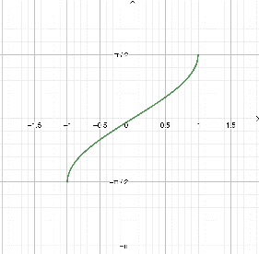
Inverse Trigonometric Functions
$y= \sin^{-1}\left(x\right)=\arcsin\left(x\right), where x=sin⁡(y)$

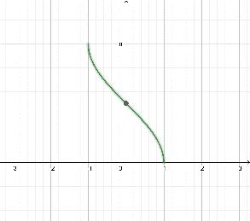
$y= \cos^{-1}\left(x\right)=arcos\left(x\right), where x=\cos\left(x\right)$

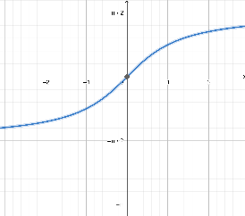
$y= \tan^{-1}\left(x\right)=\arctan\left(x\right), where x=\tan\left(y\right)$

$\sin\left(\sin^{-1}\left(x\right)\right)=x$ $\sin^{-1}\left(\sin\left(x\right)\right)=x$
$\cos\left(\cos^{-1}\left(x\right)\right)=x$ $\cos^{-1}\left(\cos\left(x\right)\right)=x$
$\tan\left(\tan^{-1}\left(x\right)\right)=x$ $\tan^{-1}\left(\tan\left(x\right)\right)=x$
$\sin\left(\cos^{-1}\left(x\right)\right)= \sqrt{1- x^{2}}$ $\cos\left(\sin^{-1}\left(x\right)\right)= \sqrt{1- x^{2}}$
$\sin\left(\tan^{-1}\left(x\right)\right)= \frac{x}{\sqrt{1- x^{2}}}$ cos ($\tan^{-1}(x))= \frac{1}{\sqrt{1- x^{2}}}$
- Law of Sines
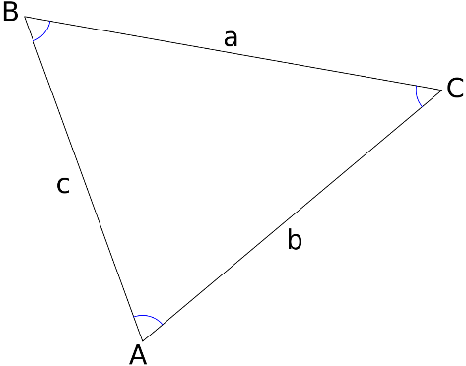
$$\frac{a}{\sin{A}}= \frac{b}{\sin{B}}= \frac{c}{\sin{C}} =2R,$$
$where R is the radius of the circumcircle of the triangle$
$$Area= \frac{1}{2}bc\sin{A= \frac{1}{2} ab}\sin{C= \frac{1}{2}} ac\sin{B}$$
AAS ASA SSA
$$\frac{\operatorname{Sin}{A}}{a}= \frac{\sin{B}}{b}= \frac{\sin{C}}{c}$$

- Law of Cosines
$$a^{2}= b^{2}+ c^{2}-2bc cos⁡(A)$$ | $$\cos\left(A\right)= \frac{b^{2}+ c^{2}- a^{2}}{2bc}$$ | $$A= \cos^{-1}(\frac{b^{2}+ c^{2}- a^{2}}{2bc})$$
$$b^{2}= a^{2}+ c^{2}-2ac cos⁡(B)$$ | $$\cos\left(B\right)= \frac{a^{2}+ c^{2}- b^{2}}{2ac}$$ | $$A= \cos^{-1}(\frac{a^{2}+ c^{2}- b^{2}}{2ac})$$
$$c^{2}= a^{2}+ b^{2}-2ab cos⁡(C)$$ | $$\cos\left(C\right)= \frac{a^{2}+ b^{2}- c^{2}}{2ab}$$ | $$A= \cos^{-1}(\frac{a^{2}+ b^{2}- c^{2}}{2ab})$$
Use the Law of Cosines for SAS SSS

- Heron’s Formula for area of triangle
Given the following triangle, the semi perimeter s is given by:
$$s=\frac{(a+b+c)}{2}$$

The area from this is given as
$$Area=\sqrt{s(s-a)(s-b)(s-c)}$$
Similarly, the inradius (the radius of a circle that exactly fits within a triangle is given by:
$$r=\sqrt{\frac{(s-a)(s-b)(s-c)}{s}}$$

- Complex Numbers
Consider a complex number $Z=a+bi$
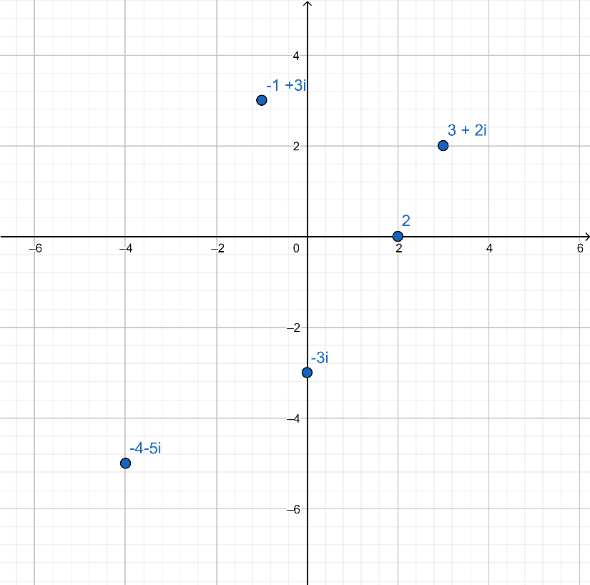
Absolute Value of complex number
|Z| =|a + bi| = $\sqrt{a^{2}+ b^{2}}$ example: |3 + 4i| = $\sqrt{3^{2}+ 4^{2}}= \sqrt{25}=5$
Trigonometric Notation for complex numbers
Note that
$a=rcos\left(θ\right)$
$$b=rsin\left(θ\right)$$
$r= \left|Z\right|$ = =|a + bi| = $\sqrt{a^{2}+ b^{2}}$
(note r is the distance to the origin)
$a+bi=r\left(\cos\left(θ\right)+isin\left(θ\right)\right)=rcis\left(θ\right)$
example: 4+ 4i = 4$\sqrt{2}cis(\frac{π}{4})$

Complex Multiplication
$r_{1}cis\left(θ_{1}\right)* r_{2}cis\left(θ_{2}\right)= r_{1}r_{2}cis\left(θ_{1}+ θ_{2}\right)$
Proof:

example: $\left(3+3i\right)*\left(1+\sqrt{3}i\right)=3\sqrt{2}cis\left(45°\right)*2cis\left(60°\right)=6\sqrt{3}cis(105°)$

Complex Division
$\frac{r_{1}cis\left(θ_{1}\right)}{r_{2}cis\left(θ_{2}\right)}= \frac{r_{1}}{r_{2}}cis\left(θ_{1}-θ_{2}\right)$
Proof:

example:
$\frac{1+i}{1-i}=\frac{\sqrt{2}cis\left(45°\right)}{\sqrt{2}cis\left(315°\right)}=cis\left(45°-315°\right)=cis\left(-270°\right)=0+i=i$

Powers of Complex Numbers
DEMOIVRE’S THEOREM
$({rcis\left(θ\right))}^{n}= r^{n}cis(nθ)$
Proof:

You can use DeMoivre’s theorem to develop the equations for multiple angle relations. For example,

Given that
$({rcis\left(θ\right))}^{2}= r^{2}cis(2θ)$
$r^{2}({cos\left(θ\right)+isin(ϑ)}^{2}= r^{2}(\cos^{2}\left(θ\right)+2isin\left(θ\right)\cos\left(θ\right)- \sin^{2}\left(θ\right)$)
$$\cos\left(2θ\right)+isin\left(2θ\right)= \sin^{2}- \cos^{2}\left(θ\right)+ i2sin\left(θ\right)\cos\left(θ\right)$$
Equate the real parts and imaginary parts:
$$isin\left(2θ\right)= i2sin\left(θ\right)\cos\left(θ\right)$$
$sin\left(2θ\right)= 2sin\left(θ\right)\cos\left(θ\right)$ QED
$\cos\left(2θ\right)$ = $\sin^{2}(θ)- \cos^{2}\left(θ\right) QED$

And this can be used for multiple angles as well.

example: ${(1+i)}^{9}= {{\left(\sqrt{2}cis\left(45°\right)\right)}^{9}= \sqrt{2}}^{9}cis\left(9*45°\right)=16\sqrt{2}cis\left(405°\right)= 16\sqrt{2}cis\left(45°\right)=16\sqrt{2}\left(\frac{\sqrt{2}}{2}+i\frac{\sqrt{2}}{2}\right)=16+16i$

Nth Roots of Complex Numbers
${\left(rcis\left(θ\right)\right)}^{\frac{1}{n}}= r^{\frac{1}{n}}\left(cis\left(\frac{θ}{n}+k*\frac{360}{n}\right)\right)$ $where k=0, 1, …n-1$
Proof:

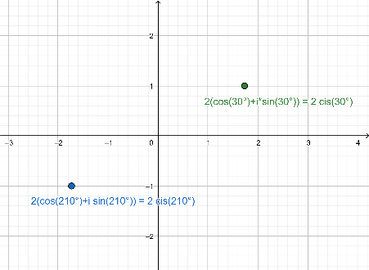
example: $take the square root of 2+2\sqrt{3}i=4cis(60°)$
$${\left(4cis\left(60°\right)\right)}^{\frac{1}{2}}=2 cis\left(\frac{60°}{2}+k*\frac{360°}{2}\right), k=0, 1$$
$$k=0 2cis\left(30°\right)$$
$$k=1 2cis\left(210°\right)$$

- Polar Coordinates

In the previous example for the square root, the answer can be expressed in polar coordinates like this:
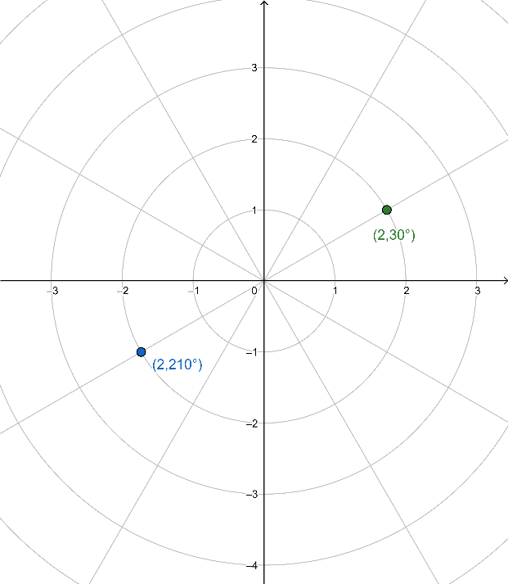

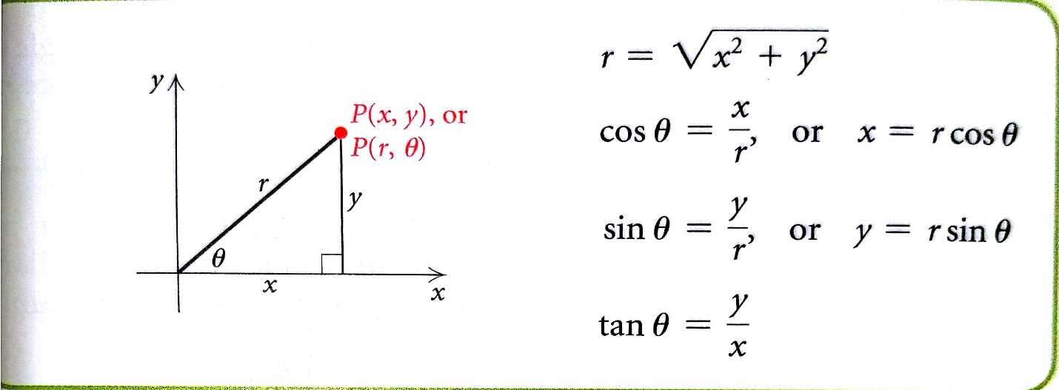

- Polar equations
Some curves that are not function in cartesian coordinates become simpler and become functions when expressed in polar coordinates:
For example, $x^{2}$+ $y^{2}=25$ is a circle at the origin and a radius of 5. It is not a function in y, but if you use the conversion from cartesian coordinates to polar, you get:
$${\left(rcos\left(θ\right)\right)}^{2}+{\left(rsin\left(θ\right)\right)}^{2}=25$$
$$r^{2}\cos^{2}(θ)+r^{2}\sin^{2}(θ)=25$$
$$r^{2}(\cos^{2}\left(θ\right)+\sin^{2}\left(θ\right))=25$$
$$r^{2}=25$$
$$r=5$$
You can also convert polar equations of the form $r= f\left(θ\right)$ to cartesian coordinates. Here is an example
$$r=\frac{6}{cos\left(θ\right)}$$
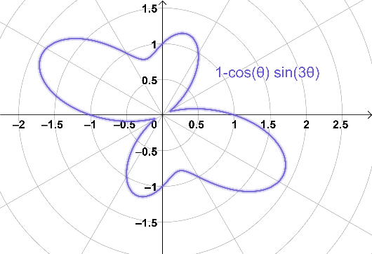
Using $x=r cos\left(θ\right)from above we see that$
$$x=6$$
Which is a straight vertical line at x=6.

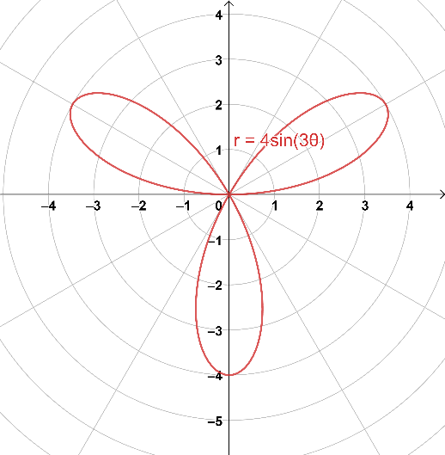
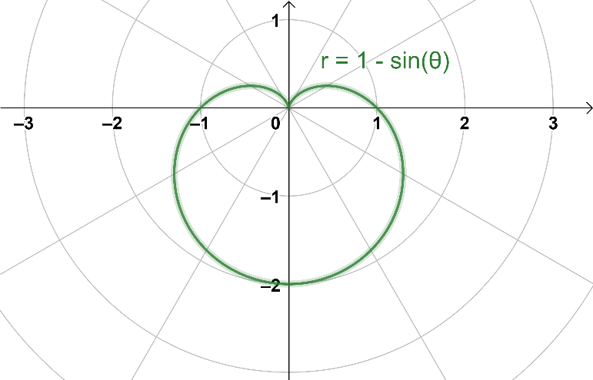

- Vectors

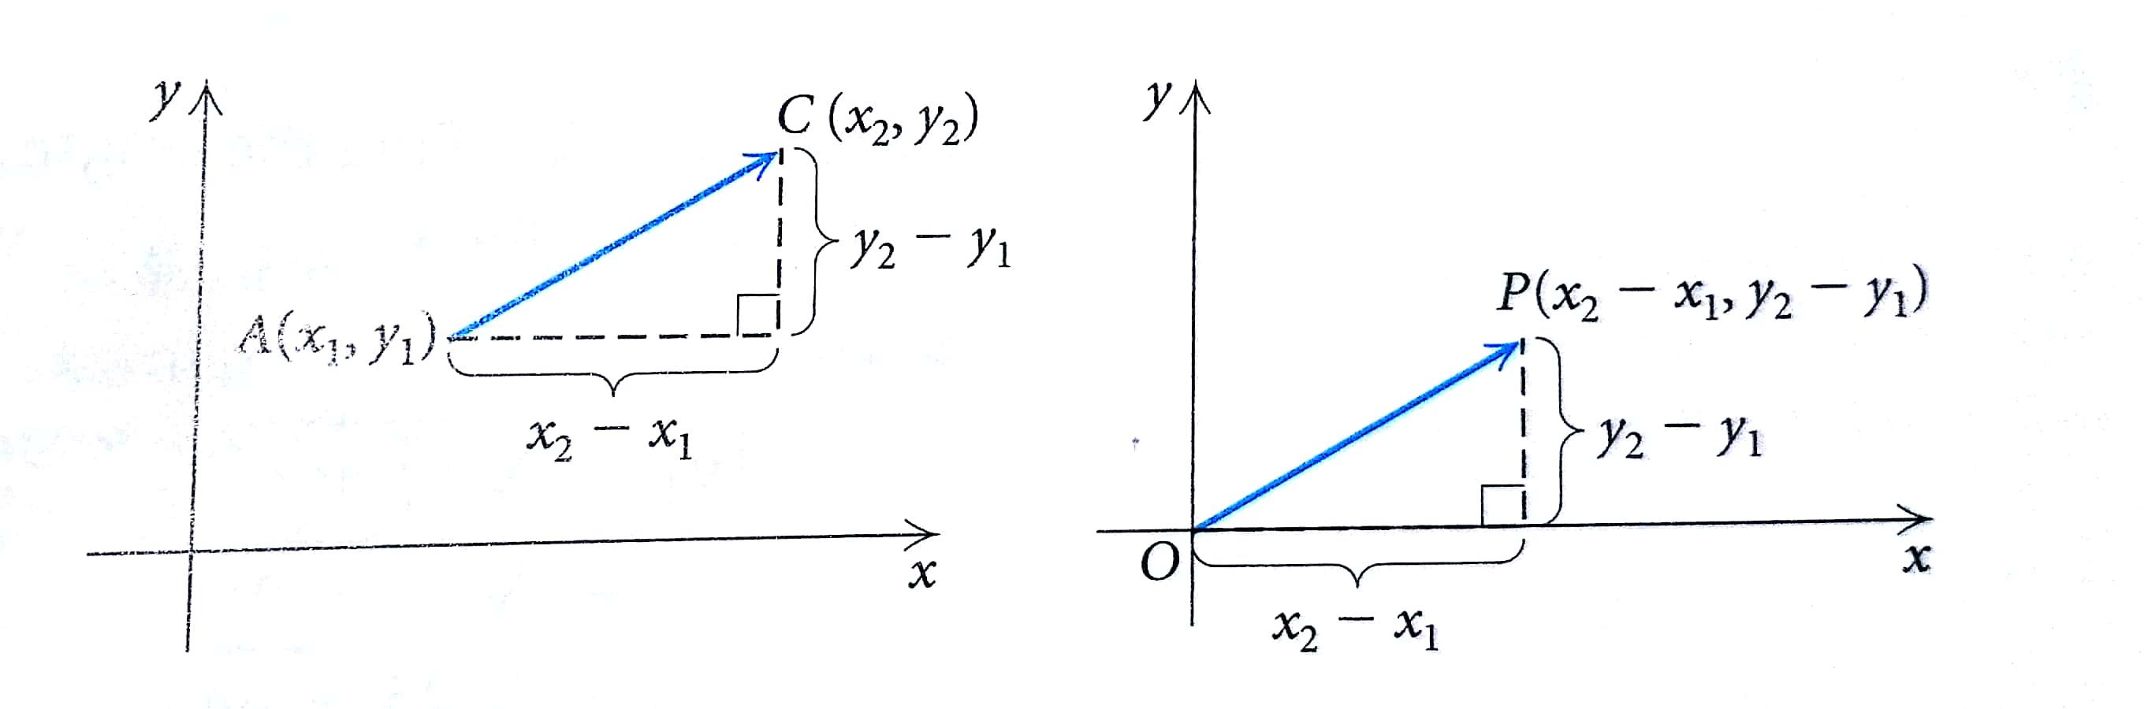

Component Form of a Vector:
Scalar Multiplication
$$\vec{AC}= <x_{2}- x_{1}, y_{2}- y_{1}>$$
$v= <v_{1}, v_{2}>$, scalar k, then
$$kv= k<v_{1}, v_{2}> = <{kv}_{1},kv_{2}>$$
Length of a vector $v= <v_{1}, v_{2}>$
$\left|v\right|= \sqrt{v_{1}^{2}+ v_{2}^{2}}$

Vector Addition/Subtraction
$$v= <v_{1}, v_{2}>$$
$$u=<u_{1}, u_{2}>$$
$$u+v= <u_{1}+v_{1},u_{2}+v_{2}>$$

Vector Properties
$$For all vectors u,v, and w, ansd for all scalars b an c,$$
$$u+v=v+u$$
$$u+\left(v+w\right)=\left(u+v\right)+w$$
$$v+0 =v$$
$$1v=v$$
$$v+\left(-v\right)=0$$
$$b\left(cv\right)=\left(bc\right)v$$
$$\left(b+c\right)v=bv+cv$$
$$b\left(u+v\right)=bu+bv$$

Unit Vectors
A vector of magnitude 1, or length, 1 is called a unit vector.
You can find the unit vector in the same direction of any vector u by dividing the vector by its scalar length.
Stated more formally,

$$If v is a vector and v ≠0,$$
$$\frac{1}{\left|v\right|}∙v , or \frac{v}{\left|v\right|},$$
$$is a unit vector in the direction of v.$$

Dot Product
The dot product of two vectors $u=<u_{1}, u_{2}>$ and $v=<v_{1}, v_{2}>$ is given by
$$u ∙v= u_{1} {v }_{1}+ u_{2} v_{2}.$$

Angle between Vectors
If $θ is the angle between two nonzero vectors u and v, then$
$$cos\left(θ\right)=\frac{u∙v}{\left|u\right|\left|v\right|}$$

- Exponents and Logarithms (Chapter 5.3, 5.4)
Exponential Functions
The function $f\left(x\right)=a^{x}, where x is a real number , a>0 and a≠0, is called the exponential function, base a.$
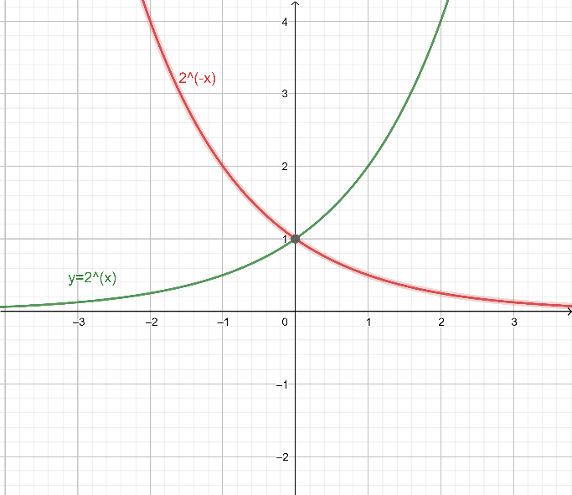
Examples: $y= 2^{x} (green), and y= 2^{-x} (red)$
Note that both functions approach the x-axis asymptotically at -∞ and +∞, respectively.
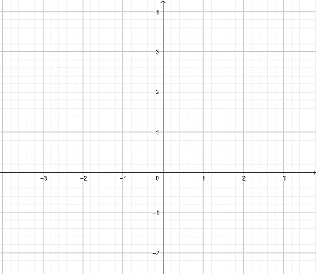
Graph $y=4^{x} below:$

Graph $y={.5}^{x} below:$ Graph $y=2^{x}+1 below:$
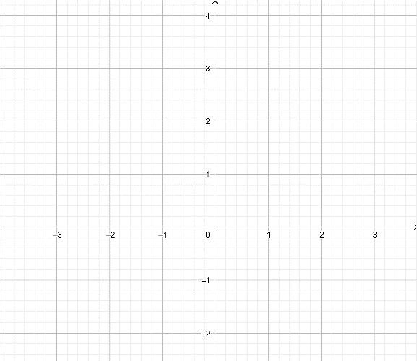

Properties of exponents
$$a^{x}*a^{y}= a^{x+y}$$
$$\frac{a^{x}}{a^{y}}= a^{x-y}$$
$${\left(a^{x}\right)}^{y}= a^{xy}$$
$${\left(ab\right)}^{x}= a^{x}b^{x}$$
$${\left(\frac{a}{b}\right)}^{x}= \frac{a^{x}}{b^{x}}$$
$$a^{-x}= \frac{1}{a^{x}}$$
$a^{\frac{1}{x}}= \sqrt[x]{a}$ relation between radicals and fractional exponents (e.g. $x^{\frac{1}{2}}= \sqrt[2]{x}$)
Solving exponential equations (e.g. $216= {36}^{3n+3}$ )
1. Find common base (e.g. $216= 6^{3} and 36= 6^{2}$)
2. exponents of common bases will be equal: ($6^{3}= {\left(6^{2}\right)}^{3n+3}= 6^{6n+6}, so 3=6n+6$)
3. solve the exponent equation $,( n= -\frac{1}{2}$)
Examples:
1. ${81}^{-n}∙{\left(\frac{1}{9}\right)}^{-n}= {81}^{3n}$ $\left\{n=0\right\}$

$2.$ $\frac{1}{216}∙{216}^{-2v-3}= \frac{1}{36}$ $\left\{v= -\frac{5}{3}\right\}$

3. ${64}^{m}∙{64}^{-2m}= {\left(\frac{1}{4}\right)}^{m+1}$ $\left\{m= \frac{1}{2}\right\}$

4. ${36}^{2p}∙{216}^{-p}= {36}^{-p-2}$ $\left\{v= -\frac{4}{3}\right\}$

Logarithm functions

Logarithms are the inverse of exponential functions:
We define $y= \log_{a}x as that number y such that x= a^{y},where x>0 and a is a positive constant ≠1.$
$$\log_{a}x=y \overset{⇔}{} x= a^{y}$$
Examples: Convert each of these to a logarithmic equation
1. $256= 2^{n}\overset{⇔}{}$

$$2. {10}^{-3}=0.001 \overset{⇔}{}$$

$3$. $a^{8}=Q \overset{⇔}{}$

$$4. t^{x}=M \overset{⇔}{}$$

Convert these to an exponential equation
1. $\log_{2}{32}=5 \overset{⇔}{}$

$$2. \log_{a}{y=x \overset{⇔}{}}$$
Change of Base formula
$$\log_{b}{M}= \frac{\log_{a}{M}}{\log_{a}{b}}$$
$$Example:$$
$find \log_{5}{8}$ using common (base 10) logarithms
$\log_{5}{8}= \frac{\log_{10}{8}}{\log_{10}{5}}$ = 1.2920 (calculator)

Properties of Logarithmic functions
Product Rule
For any positive numbers M and N and any logarithm base a,
$$\log_{a}{MN}= \log_{a}{M}+\log_{a}{N}$$
Power Rule
$$\log_{a}{M^{p}=p \log_{a}{M}}$$
Quotient Rule
$$\log_{a}{\frac{M}{N}}= \log_{a}{M}- \log_{a}{N}$$
Logarithm of a base to a power
$\log_{a}{a^{x}}=x$, ${ a}^{\log_{a}{x}}=x$
Swap base with exponent rule:
$$\log_{a}b=1/\log_{a}b$$
Change of Base formula
$$\log_{b}{a}= \frac{\log_{a}{a}}{\log_{a}{b}}$$
also
$$\log_{c}b* \log_{b}a=\log_{c}a$$
Express each of these in terms of sums and differences of powers
1. $\log_{a}{\frac{x^{2}y^{5}}{z^{4}}}$

2. $\log_{a}{\sqrt[3]{\frac{a^{2}b}{c^{5}}}}$

Express as a single logarithm
1. $5\log_{b}{x}- \log_{b}{y}+ \frac{1}{4}\log_{b}{z}$
2. ln(3x+1) – ln(3$x^{2}-5x-2)$
Other Properties:
$$\log_{a}{a}=1$$
$$\log_{a}{1}=0$$
$\log_{a}{M}= \log_{a}{N} \overset{⇔}{}$M =
- Solutions of linear equations

Matrices

Augmented Matrices
$\left[\begin{matrix}a_{1} & b_{1} & c_{1} \\ a_{2} & b_{2} & c_{2} \\ a_{3} & b_{3} & c_{3}\end{matrix}\left|\begin{matrix}d_{1} \\ d_{2} \\ d_{3}\end{matrix}\right.\right]$ represents the system of equations : $\begin{matrix}a_{1}x+ b_{1}y+ c_{1}z= d_{1} \\ a_{2}x+ b_{2}y+ c_{2}z= d_{2} \\ a_{3}x+ b_{3}y+ c_{3}z= d_{3}\end{matrix}$
Row-Echelon Form
$\left[\begin{matrix}1 & b_{1} & c_{1} \\ 0 & 1 & c_{2} \\ 0 & 0 & 1\end{matrix}\right]\left[\begin{matrix}d_{1} \\ d_{2} \\ d_{3}\end{matrix}\right]$ represents the system of equations: $\begin{matrix}x+ b_{1}y+ c_{1}z= d_{1} \\ 0x+ y+ c_{2}z= d_{2} \\ 0x+ 0y+ z= d_{3}\end{matrix}$ : $\begin{matrix}x+ b_{1}y+ c_{1}z= d_{1} \\ y+ c_{2}z= d_{2} \\ z= d_{3}\end{matrix}$
Reduced Row-Echelon Form
$\left[\begin{matrix}1 & 0 & 0 \\ 0 & 1 & 0 \\ 0 & 0 & 1\end{matrix}\right]\left[\begin{matrix}d_{1} \\ d_{2} \\ d_{3}\end{matrix}\right]$ represents the system of equations: $\begin{matrix}x+ 0y+ 0z= d_{1} \\ 0x+ y+ 0z= d_{2} \\ 0x+ 0y+ z= d_{3}\end{matrix}$ : $\begin{matrix}x= d_{1} \\ y= d_{2} \\ z= d_{3}\end{matrix}$
Row-Equivalent Operations
- Interchange and two rows
- Multiply each entry in a row by the same non-zero constant
- Add a non-zero multiple of one row to another row

Addition and Subtraction of Matrices
Given two m x n (row x column) matrix:
A = $\left[a_{ij}\right]$ = $\left[\begin{matrix}a_{11} & ⋯ & a_{1n} \\ ⋮ & ⋱ & ⋮ \\ a_{m1} & ⋯ & a_{mn}\end{matrix}\right]$ B = $\left[b_{ij}\right]$ = $\left[\begin{matrix}b_{11} & ⋯ & b_{1n} \\ ⋮ & ⋱ & ⋮ \\ b_{m1} & ⋯ & b_{mn}\end{matrix}\right]$
A + B = $\left[\begin{matrix}{a_{11}+b}_{11} & ⋯ & {a_{1n}+ b}_{1n} \\ ⋮ & ⋱ & ⋮ \\ a_{m1}+ b_{m1} & ⋯ & {a_{mn}+b}_{mn}\end{matrix}\right]$ A - B = $\left[\begin{matrix}{a_{11}-b}_{11} & ⋯ & {a_{1n}- b}_{1n} \\ ⋮ & ⋱ & ⋮ \\ a_{m1}- b_{m1} & ⋯ & {a_{mn}-b}_{mn}\end{matrix}\right]$
examples
1. $\left[\begin{matrix}2 & 0 \\ -1 & 3\end{matrix}\right]+\left[\begin{matrix}-1 & -6 \\ -2 & 4\end{matrix}\right]$

2. $\left[\begin{matrix}5 & -1 \\ -5 & 5\end{matrix}\right]-\left[\begin{matrix}1 & 6 \\ 5 & 6\end{matrix}\right]$

3. $\left[\begin{matrix}2 \\ -2\end{matrix}\right]+\left[\begin{matrix}2 \\ 4\end{matrix}\right]$

4. $\left[\begin{matrix}-2 & -3 & -6\end{matrix}\right]+\left[\begin{matrix}-1 & 5 & 5\end{matrix}\right]$

Scalar Product
The scalar product of a number k and a matrix A is the matrix denoted kA, as follows:
kA = $\left[ka_{ij}\right]$ = $\left[\begin{matrix}ka_{11} & ⋯ & ka_{1n} \\ ⋮ & ⋱ & ⋮ \\ {ka}_{m1} & ⋯ & ka_{mn}\end{matrix}\right]$

Properties of Addition and scalar multiplication
A + B = B + A Commutative Property of Addition
A + (B + C) = (A + B) + C Associative Property of Addition
(kl)A = k(lA) Associative Property of Scalar Multiplication
k(A + B) = kA + kB Distributive Property
(k + l)A = kA + lA Distributive Property
There exists a unique matrix 0 such that:
A + 0 = 0 + A = A Additive Identity Property
There exists a unique matrix -A such that:
A + (-A) = -A + A = 0 Additive inverse Property

Matrix Multiplication
A $∙$B = $\left[\begin{matrix}{a_{11}∙b}_{11}+ {a_{12}∙b}_{21}+ {a_{13}∙b}_{31}+ ⋯ & ⋯ & {a_{m1}∙b}_{11}+ {a_{12}∙b}_{21}+ {a_{13}∙b}_{31}+ ⋯ \\ ⋮ & ⋱ & ⋮ \\ {{ a}_{11}∙b}_{m1}+ {a_{21}∙b}_{m2}+ {a_{31}∙b}_{m3}+ ⋯ & ⋯ & {{ a}_{m1}∙b}_{1n}+ {a_{m2}∙b}_{2n}+ {a_{m3}∙b}_{3n}+ ⋯\end{matrix}\right]$
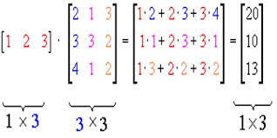
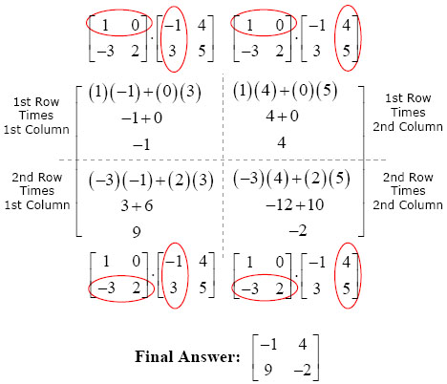
Note that the number of rows in A and the number of columns of B must be the same.

Example Problems:
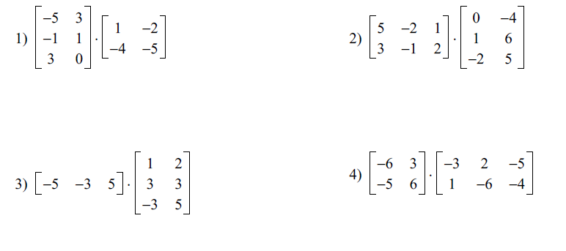

Properties of Matrix Multiplication
A(BC) = (AB)C Associative Property of Multiplication
A(B + C) = AB + AC Distributive Property of Multiplication
(B + C)A = BA + CA Distributive Property of Multiplication
AB ≠ BA Commutative property not always applicable
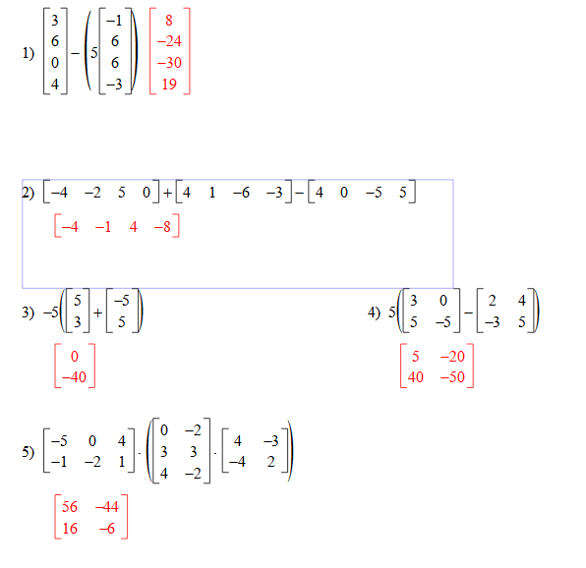

The Identity Matrix
An n x n matrix with 1’s on the main diagonal and 0’s elsewhere.
I = $\left[\begin{matrix}\begin{matrix}1 & 0 \\ 0 & 1\end{matrix} & \begin{matrix}0 & 0 \\ 0 & 0\end{matrix} & \begin{matrix}0 ⋯ & 0 \\ 0 ⋯ & 0\end{matrix} \\ \begin{matrix}0 & 0 \\ 0 & 0\end{matrix} & \begin{matrix}1 & 0 \\ 0 & 1\end{matrix} & \begin{matrix}0 ⋯ & 0 \\ 0 ⋯ & 0\end{matrix} \\ \begin{matrix}⋮ & ⋮ \\ 0 & 0\end{matrix} & \begin{matrix}⋮ & ⋮ \\ 0 & 0\end{matrix} & \begin{matrix}⋮ & ⋮ \\ 0 ⋯ & 1\end{matrix}\end{matrix}\right]$
Such that A x I = I x A = A
Matrix Inverse
The Inverse of a Matrix is a matrix $A^{-1} such that A^{-1}*A =I\left(unity matrix\right)$
Matrix inverse of 2x2 matrix:
Given $\left[\begin{matrix}a & c \\ b & d\end{matrix}\right], the inverse is given by \left[\begin{matrix}d & -c \\ -b & a\end{matrix}\right]/det\left[\begin{matrix}a & c \\ b & d\end{matrix}\right]$
Finding the Inverse Matrix of an arbitrary nxn matrix
Gaussian Elimination:
For a 2x2 matrix, the inverse can be found by doing a Gaussian elimination of an augmented matrix with the Identity matrix:
$\left[\begin{matrix}a_{1} & b_{1} & c_{1} \\ a_{2} & b_{2} & c_{2} \\ a_{3} & b_{3} & c_{3}\end{matrix}\left|\begin{matrix}1 & 0 & 0 \\ 0 & 1 & 0 \\ 0 & 0 & 1\end{matrix}\right.\right]$ to produce $\left[\begin{matrix}1 & 0 & 0 \\ 0 & 1 & 0 \\ 0 & 0 & 1\end{matrix}\left|\begin{matrix}a_{1} & b_{1} & c_{1} \\ a_{2} & b_{2} & c_{2} \\ a_{3} & b_{3} & c_{3}\end{matrix}\right.\right]$ where the right hand is the inverse matrix.
Examples: (using Gaussian elimination)
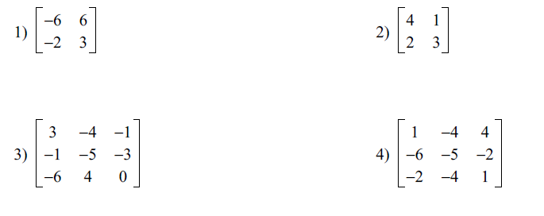

Determinants:
With every square (only) matrix, we associate a scalar value called it’s determinant.

The Determinant of a square 2x2 matrix
$$\left[\begin{matrix}a & c \\ b & d\end{matrix}\right] is denoted as \left|\begin{matrix}a & c \\ b & d\end{matrix}\right| and is defined as$$
$$\left|\begin{matrix}a & c \\ b & d\end{matrix}\right|=ad-bc$$

Examples: Find the determinant of each of these 2x2 matrices

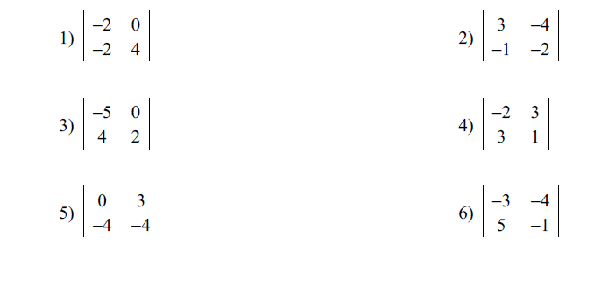

Matrix Cofactors and Minors
Matrices of order higher than 2x2 can be evaluated by using cofactors and minors.
MINOR
For a square matrix $A=\left[a_{ij}\right], the Minor M_{ij}of an entry a_{ij}$is the determinant of the matrix formed by deleting the ith row and the jth column of A.

Example: (4x4)
$$A=\left[a_{ij}\right]= \left\lceil \begin{matrix}-4 & 2 & 5 & -1 \\ 6 & 0 & 1 & 2 \\ 4 & 3 & 0 & -3 \\ -5 & 1 & -1 & 2\end{matrix}\right\rceil$$
Find $M_{11} and M_{23}$

$$M_{11}=\left\lceil \begin{matrix} & & & \\ & 0 & 1 & 2 \\ & 3 & 0 & -3 \\ & 1 & -1 & 2\end{matrix}\right\rceil =\left|\begin{matrix}0 & 1 & 2 \\ 3 & 0 & 3 \\ 1 & -1 & 2\end{matrix}\right|.$$

$$M_{23}=\left\lceil \begin{matrix}-4 & 2 & & -1 \\ & & & \\ 4 & 3 & & -3 \\ -5 & 1 & & 2\end{matrix}\right\rceil =\left|\begin{matrix}-4 & 2 & -1 \\ 4 & 3 & -3 \\ 5 & 1 & 2\end{matrix}\right|.$$
For A = $\left|\begin{matrix}0 & 1 & 2 \\ 3 & 0 & 3 \\ 1 & -1 & 2\end{matrix}\right|., find M_{11}, M_{12}, and M_{13}.$

For A = $\left|\begin{matrix}-4 & 2 & -1 \\ 4 & 3 & -3 \\ 5 & 1 & 2\end{matrix}\right|. find M_{21}, M_{22}, and M_{23}$

COFACTORS
Let A be an n × n matrix. The cofactor, $C_{ij}$, of the element${ a}_{ij}$, is defined by $C_{ij}$ $={(-1)}^{i+j}M_{ij}$ , where $M_{ij}$ is the minor of $a_{ij}$ .

Example:$find C_{11}, C_{23}, C_{31 for }$
$$A= \left[\begin{matrix}2 & 1 & 3 \\ -1 & 4 & -2 \\ 3 & 1 & 5\end{matrix}\right],$$
$$C_{11}=+ M_{11}=+\left|\begin{matrix}4 & -2 \\ 1 & 5\end{matrix}\right|=+\left((4)*(5)-(1)*(-2)\right)=22.$$
$$C_{23}=- M_{23}=-\left|\begin{matrix}2 & 1 \\ 3 & 1\end{matrix}\right|=-\left((2)*(1)-(3)*(1)\right)=1.$$
$$C_{31}=+ M_{31}=+\left|\begin{matrix}1 & 3 \\ 4 & -2\end{matrix}\right|=\left((1)*(-2)-(4)*(3)\right)=-14.$$

For the following matrices, find all cofactors of the given matrix.

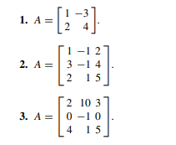

Using Cofactors to find the determinant of a larger matrix.
For any square matrix A, that is nxn, we define the determinant of A denoted as $\left|A\right|$ as follows:
1. Choose ANY row or column.
2. Multiply each element in that row or column by its cofactor and add the results.
3. The value of the determinant will be the same regardless of which row or column you choose (so choose wisely).
Example:
Let $\left|A\right|= \left|\begin{matrix}-8 & 0 & 6 \\ 4 & -6 & 7 \\ -1 & -3 & 5\end{matrix}\right|$
Expanding across the third row gives:
$$\left|A\right|=\left(+\right)\left(-1\right)\left|\begin{matrix}0 & 6 \\ -6 & 7\end{matrix}\right|+\left(-\right)\left(-3\right)\left|\begin{matrix}-8 & 6 \\ 4 & 7\end{matrix}\right|+\left(+\right)(5)\left|\begin{matrix}-8 & 0 \\ 4 & -6\end{matrix}\right|$$
$$\left|A\right|=-6\left(0+36\right)+3\left(-56-24\right)+5\left(48-0\right)$$
$\left|A\right|=-6\left(36\right)+3\left(-80\right)+5\left(48\right)$ = -36

Find the following determinants by the cofactor technique:
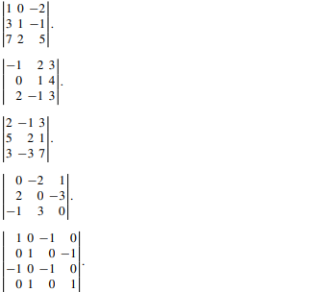
Using Augmented Matrix to find the Determinant (Shortcut method)
Let $\left|A\right|= \left|\begin{matrix}-8 & 0 & 6 \\ 4 & -6 & 7 \\ -1 & -3 & 5\end{matrix}\right|$

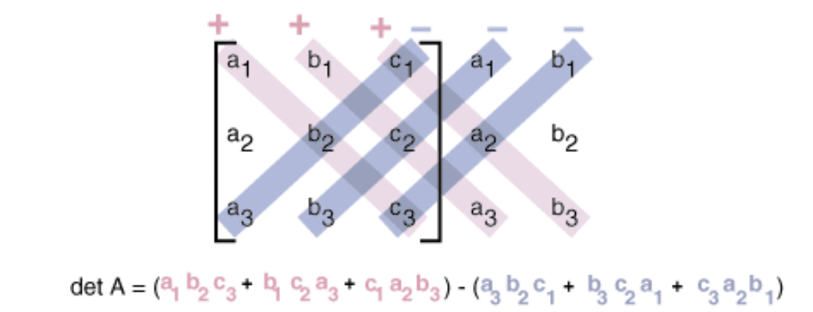
Make an augmented matrix with the first two columns of the 3x3 matrix as follows:
$$\left|\begin{matrix}-8 & 0 & 6 \\ 4 & -6 & 7 \\ -1 & -3 & 5\end{matrix}\right|\left.\begin{matrix}-8 & 0 \\ 4 & -6 \\ -1 & -3\end{matrix}\right|$$

Add all the top to bottom diagonals multiplied together, i.e. (-8)*(-6)*(5) + (0)*(7)*(-1) + (6)*(4)*(-3) = 240+0-72 = 168
Then subtract all the bottom to top diagonals multiplied together, i.e. (-1)*(-6)*(6)+(-3)*(7)*(-8) + (5)*(4)*(0) = 36+168+0=204
168-204 = -36, which is the same result (thankfully!) when we did it using cofactors.
Find the determinants using the shortcut method:

Matrix Inverses
The inverse of an array can be found by dividing the adjugate (or adjoint) of the matrix by the determinant of the matrix:
$$A^{-1}= \frac{1}{Det(A)}*Adj(A)$$
The adjoint of a matrix is the cofactor matrix transposed:
$$A= \left[\begin{matrix}a_{0} & b_{0} & c_{0} \\ a_{1} & b_{1} & c_{1} \\ a_{2} & b_{2} & c_{2}\end{matrix}\right], cofactor matrix C= \left[-\begin{matrix}\left[\begin{matrix}b_{1} & c_{1} \\ b_{2} & c_{2}\end{matrix}\right] & -\left[\begin{matrix}a_{1} & c_{1} \\ a_{2} & c_{2}\end{matrix}\right] & \left[\begin{matrix}a_{1} & b_{1} \\ a_{2} & b_{2}\end{matrix}\right] \\ \left[\begin{matrix}b_{0} & c_{0} \\ b_{2} & c_{2}\end{matrix}\right] & \left[\begin{matrix}a_{0} & c_{0} \\ a_{2} & c_{2}\end{matrix}\right] & -\left[\begin{matrix}a_{0} & b_{0} \\ a_{2} & b_{2}\end{matrix}\right] \\ \left[\begin{matrix}b_{0} & c_{0} \\ b_{1} & c_{1}\end{matrix}\right] & -\left[\begin{matrix}a_{0} & c_{0} \\ a_{1} & c_{1}\end{matrix}\right] & \left[\begin{matrix}a_{0} & b_{0} \\ a_{1} & b_{1}\end{matrix}\right]\end{matrix}\right],$$
$cofactor matrix C= \left|\begin{matrix}b_{1}c_{2}-b_{2}c_{1} & & \\ & & \\ & & a_{0}b_{1}-a_{1}b_{0}\end{matrix}\right|$=$\left|\begin{matrix}d_{0} & e_{0} & f_{0} \\ d_{1} & e_{1} & f_{1} \\ d_{2} & e_{2} & f_{2}\end{matrix}\right|.$
Transposed matrix $C^{T}= {\left|\begin{matrix}d_{0} & e_{0} & f_{0} \\ d_{1} & e_{1} & f_{1} \\ d_{2} & e_{2} & f_{2}\end{matrix}\right|}^{T}= \left|\begin{matrix}d_{0} & d_{1} & d_{2} \\ e_{0} & e_{1} & e_{2} \\ f_{0} & f_{1} & f_{2}\end{matrix}\right|$
Example for 2x2:
A = $\left[\begin{matrix}a_{0} & b_{0} \\ a_{1} & b_{1}\end{matrix}\right]$ $A^{-1}= \frac{1}{(a_{0}b_{1}- a_{1}b_{0})}*\left[\begin{matrix}b_{1} & {-b}_{0} \\ {-a}_{1} & a_{0}\end{matrix}\right]$
Given A = $\left[\begin{matrix}1 & -3 \\ -7 & 3\end{matrix}\right]$, $A^{-1}= \frac{1}{(1*3-\left(-3\right)*(-7)}\left[\begin{matrix}3 & 3 \\ 7 & 1\end{matrix}\right]$ = - $\frac{1}{18}\left[\begin{matrix}3 & 3 \\ 7 & 1\end{matrix}\right]$.
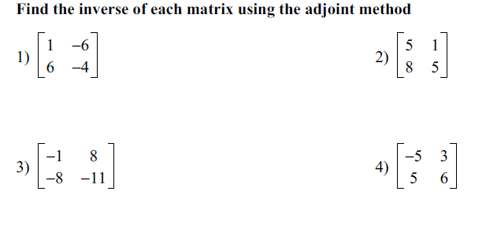
Cramer’s Rule

For a system of linear equations, the solution can be found in the following manner,
$$a_{1}x+ b_{1}y+ c_{1}z=d_{1}$$
$a_{2}x+ b_{2}y+ c_{2}z=d_{2}$
$a_{3}x+ b_{3}y+ c_{3}z=d_{3}$
$$\left[\begin{matrix}a_{1} & b_{1} & c_{1} \\ a_{2} & b_{2} & c_{2} \\ a_{3} & b_{3} & c_{3}\end{matrix}\right]\left[\begin{matrix}x \\ y \\ z\end{matrix}\right]= \left[\begin{matrix}d_{1} \\ d_{2} \\ d_{3}\end{matrix}\right]$$
A x = B
X = $A^{-1} B$

Cramers’s Rule allows us to calculate the solution without taking an inverse:
$D_{x}= \left|\begin{matrix}d_{1} & b_{1} & c_{1} \\ d_{2} & b_{2} & c_{2} \\ d_{3} & b_{3} & c_{3}\end{matrix}\right|$ $D_{y}= \left|\begin{matrix}a_{1} & d_{1} & c_{1} \\ a_{2} & d_{2} & c_{2} \\ a_{3} & d_{3} & c_{3}\end{matrix}\right|$ $D_{z}= \left|\begin{matrix}a_{1} & b_{1} & d_{1} \\ a_{2} & b_{2} & d_{2} \\ a_{3} & b_{3} & d_{3}\end{matrix}\right|$
$D= \left|\begin{matrix}a_{1} & b_{1} & c_{1} \\ a_{2} & b_{2} & c_{2} \\ a_{3} & b_{3} & c_{3}\end{matrix}\right|$
x = $\frac{D_{x}}{D}$ y = $\frac{D_{y}}{D}$ z = $\frac{D_{z}}{D}$
Applications of Matrices
Finding the area of an arbitrary triangle given the coordinates
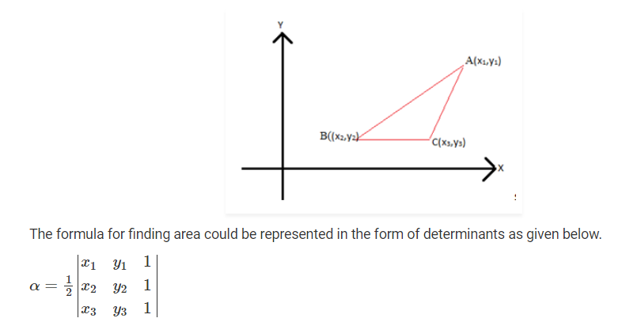

- Conic Sections
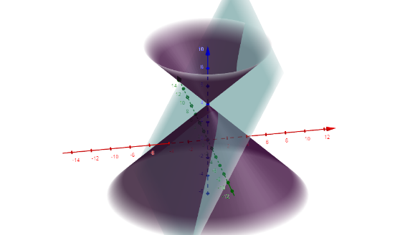
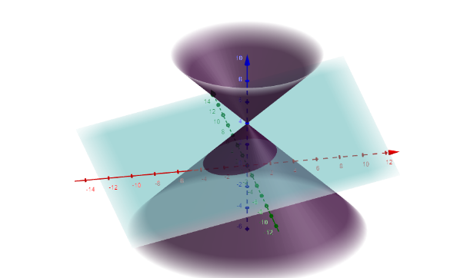
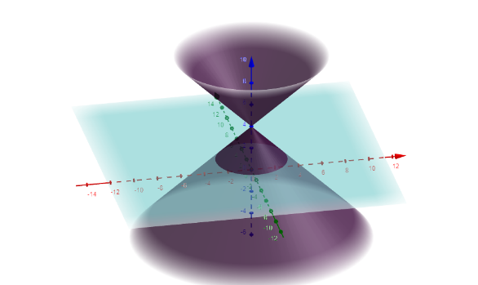

Circle Ellipse Hyperbola

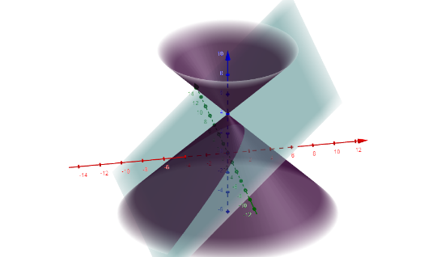

Parabola

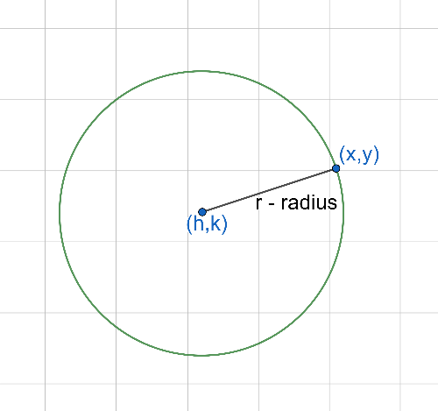
18. Circles
Equation of a circle
From the Pythagorean theorem:
$${\left(x-h\right)}^{2}+{\left(y-k\right)}^{2}=r^{2}$$

19. Ellipses
The locus of all points equidistant to two points
$$\frac{{\left(x-h\right)}^{2}}{a^{2}}+\frac{{\left(y-k\right)}^{2}}{b^{2}}=1$$

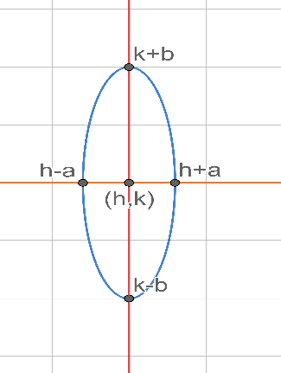
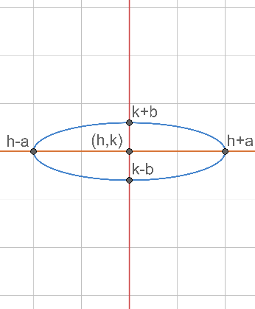

$a>b$ $b>a$
$$a^{2}= f^{2}+b^{2} b^{2}=f^{2}+a^{2}$$

20. Hyperbola

$\frac{{\left(x-h\right)}^{2}}{a^{2}}-\frac{{\left(y-k\right)}^{2}}{b^{2}}=1$ $\frac{{\left(y-k\right)}^{2}}{b^{2}}-\frac{{(x-h)}^{2}}{a^{2}}=1$
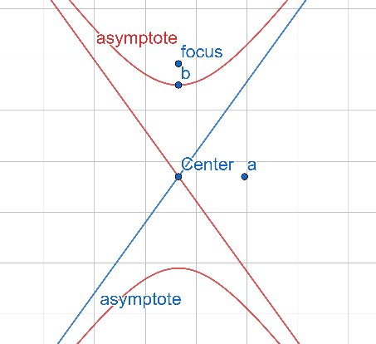
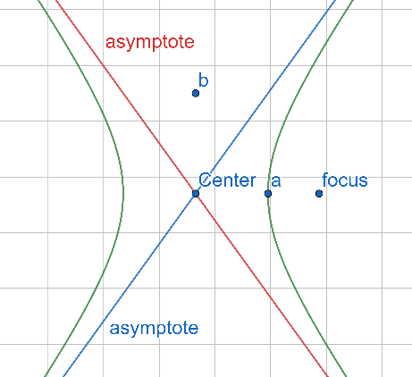

Asymptotes: $y= ±\frac{b}{a}\left(x-h\right)+k$
$f^{2}= a^{2}+b^{2}$

21. Parabola
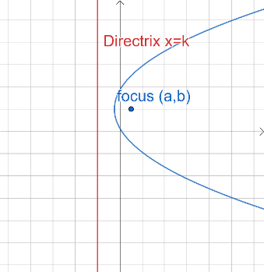
The locus of all point equidistant from a point (focus) and a line.
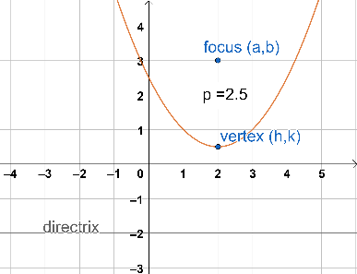

$y= \frac{{\left(x-a\right)}^{2}}{2\left(b-d\right)}+\frac{1}{2}\left(b+d\right)$ $x= \frac{{\left(y-b\right)}^{2}}{2\left(a-d\right)}+\frac{1}{2}\left(a+d\right)$

$y=\frac{{(x-h)}^{2}}{4p}+k x=\frac{{(y-k)}^{2}}{4p}+h$
Standard form where p = distance from vertex to directrix

22. Sequences (11.1)
An infinite Sequence is a function having for its domain the set of positive integers, {1,2,3,4,5…}.

A finite sequence is a function having for its domain a set of positive integers, {1,2,3,4,5,…,n} , for some positive integer n.

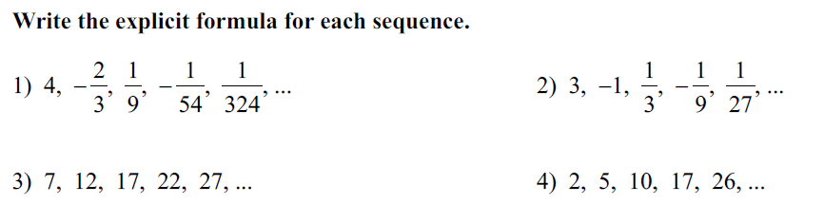

Answer:
1.

2.

3.

4.

For every one of these find the next term.

23. Series
given the infinite sequence, $a_{1}, a_{2},a_{3},a_{4},a_{5},a_{6},…a_{n},…$
the sum of the terms,
$a_{1}+ a_{2}+a_{3}+a_{4}+a_{5}+a_{6}+…a_{n}+…$
is called an infinite series. A partial sum is the sum of the first n terms,
$$a_{1}+ a_{2}+a_{3}+a_{4}+a_{5}+a_{6}+…a_{n}$$

A partial sum is also called a finite series or nth partial sum and is denoted by $S_{n}$.

Sigma notation or Summation notation
The upper case Greek letter sigma $(Σ)$ is used to denote summations.

$\sum_{i=1}^{n}{a_{i}}$₌${ a}_{1}+ a_{2}+a_{3}+a_{4}+a_{5}+a_{6}+…a_{n}$
Find and evaluate the following sums:
_{1.} $\sum_{k=1}^{5}{k^{3}}$

_{2.} $\sum_{k=0}^{4}{{\left(-1\right)}^{k}5^{k}}$

_{3.} $\sum_{i=8}^{11}{(2+\frac{1}{i})}$

Write Sigma notation for these sums:
_{1.} $1+2+4+8+16+32+64$

_{2.} $-2+4-6+8-10$

_{3.} $x+\frac{x^{2}}{2}+\frac{x^{3}}{3}+\frac{x^{4}}{4}+…$

Recursive Definitions
A sequence may be defined recursively by using a recursive formula
Example:
Find the first 5 terms of the sequence defined by
$$a_{1}=5, a_{n+1}=2a_{n}-3, for n≥1.$$
$$a_{1}=5$$
$$a_{2}=2a_{1}-3=2∙5-3=7$$
$$a_{3}=2a_{2}-3=2∙7-3=11$$
$$a_{4}=2a_{3}-3=2∙11-3=19$$
$$a_{5}=2a_{4}-3=2∙19-3=35$$
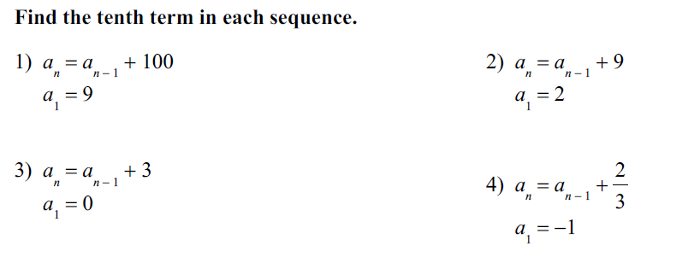

Arithmetic Sequences and Series (11.2)
A sequence is arithmetic is there exists a number d, called the common difference, such that $a_{n+1}= a_{n}+d$ for any integer n >= 1.
$n^{th}$term of am arithmetic sequence
The nth term of an arithmetic sequence is given by $a_{n}= a_{1}+\left(n-1\right)d ,$for any integer n>=1.
Sum of the first n-terms of an arithmetic sequence

$$S_{n}= \frac{n}{2}\left(a_{1}+ a_{n}\right)$$

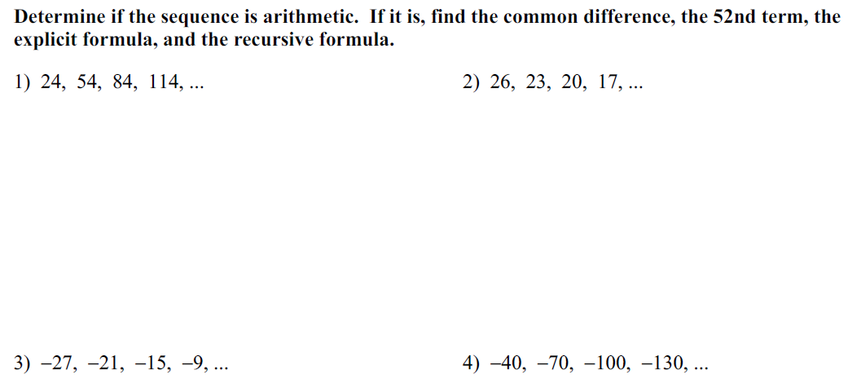

Geometric Sequences
A sequence is geometric is there is a number r, called the common ratio, such that

$\frac{a_{n+1}}{a_{n}}$= r, or $a_{n+1}=r a_{\begin{aligned}n, for any n≥1. \\ \end{aligned}}$

nth term of a geometric sequence

The nth term of a geometric sequence is given by
$$a_{n}= a_{1}r^{n-1}$$

Sum of first n terms of a geometric sequence is given by
$$S_{n}= \frac{a_{1}(1-r^{n})}{1-r}, for r≠1.$$

Sum of infinite geometric sequence is given by
$$S_{∞}= \frac{a_{1}}{1-r}.$$
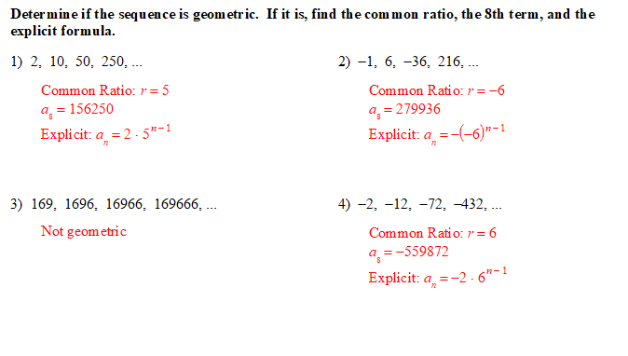

24. The principle of mathematical Induction
We can prove an infinite sequence of statements S_{n} by showing the following:
Basic Step: S₁ is true
Induction step: For all natural numbers k, S_{k}->S_{k+1.}
prove: $11+13+19+…+4n+7=n\left(2n+9\right)$
Anchor Step: $P_{1}=4\left(1\right)+7=1\left(2\left(1\right)+9\right)=11$
Inductive Hypothesis: Assume P_{k} is true
$$P_{k}=11+13+19+…+4k+7=k\left(2k+9\right)$$
Inductive Step: We now show that P_{k+1} is true.
$11+13+19+…+4k+7+4\left(k+1\right)+7=k\left(2k+9\right)$+4(k+1)+7
$P_{k+1}= P_{k}+4\left(k+1\right)+7=k\left(2k+9\right)$+4(k+1)+7
$$P_{k+1}=2k^{2}+9k+4k+4+7$$
$$P_{k+1}=2k^{2}+13k+11$$
$$P_{k+1}=2k^{2}+4k+2+9k+9$$
$$P_{k+1}=2\left(k^{2}+2k+1\right)+9\left(k+1\right)$$
$$P_{k+1}=2{\left(k+1\right)}^{2}+9\left(k+1\right)$$
$$P_{k+1}=\left(k+1\right)\left(2\left(k+1\right)+9\right)$$
prove: $40+184+424+…+{48n}^{2}-8={8n}^{2}\left(2n+3\right)$
prove: $10+46+106+…+12n^{2}-2={2n}^{2}\left(2n+3\right)$
prove: $1+9+25+…+{(2n-1)}^{2}=\frac{n\left(4n^{2}-1\right)}{3}$

25. Combinatorics

The Fundamental Counting Principle
Given a combined action, or event, in which the first action can be performed in n₁ ways, the second action can be performed in n₂ ways, and so on, the total number of ways in which the combined action can be performed is the product
n₁ n₂ n₃ n₄ … n_{k}
So how many combinations are there in a 5 digit number?
Ans: each digit has 10 possible values, 0,1,2,3,…,9
So total combinations is 10*10*10*10*10 = 100,000
Find the total number of combinations of each of these.

1.A pizza stand offers both hand-tossed and pan pizza. Customers can add any combination of the ten available toppings.

2. A jewelry store sells gold and platinum rings. Each ring is available in nine styles
and is fitted with one of ten gemstones.

3. A spinner can land on either red or blue. You spin eight times.

PERMUTATIONS
A permutation of a set of n objects is an ordered arrangement of all n objects.
The Total number of permutations of n Objects
The total number of permutations of n objects, denoted _{n}P_{m} is given by
_{n}P_{n} = n(n-1)(n-2)(n-3)…3$∙2∙1=n!$

Permutations of n Objects taken k at a time
A permutation of a set of n objects taken k at a time is a ordered arrangement of k objects taken from the set.
_{n}P_{k} = $\frac{n!}{\left(n-k\right)!}$
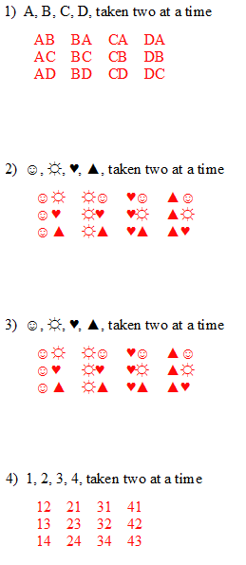

Combinations: Notation
A combination containing k objects chosen from a set of n objects, k$≤n$, is denoted using combination notation _{n}C_{k}. Order does not matter, i.e. abc = bac = cab, etc.
This is given by
_{n}C_{k} $= \frac{n!}{k!\left(n-k\right)!}$
For the following are these permutations or combinations?
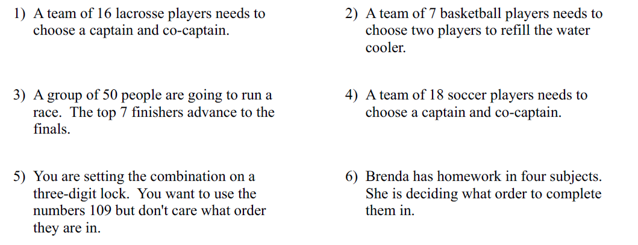

Binomial Coefficient Notation
$\left({n \atop k}\right)=$_{n}C_{k}

$$Pascal^{'}s Triangle$$
1
1 1
1 2 1
1 3 3 1
1 4 6 4 1
1 5 10 10 5 1
Pascal’s Triangle can be used to solve the power of the sum of two numbers a and b, like ${\left(a+b\right)}^{n} in the following way (notice the coefficients are shown in Pascal^{'}s triangle):$

$${\left(a+b\right)}^{0}=1$$
$${\left(a+b\right)}^{1}=a+b$$
$${\left(a+b\right)}^{2}= a^{2}+2ab+ b^{2}$$
$${\left(a+b\right)}^{3}= a^{3}+3a^{2}b+3{ab}^{2}+b^{3}$$
$${\left(a+b\right)}^{4}= a^{4}+{4a}^{3}b+6a^{2}b^{2}+4ab^{3}+b^{4}$$
$$and so forth$$

Pascal’s triangle can be also used to solve _{n}C_{k or} $\left({n \atop k}\right)$, because of the following relationship

$$\left({0 \atop 0}\right)$$
$$\left({1 \atop 0}\right) \left({1 \atop 1}\right)$$
$$\left({2 \atop 0}\right) \left({2 \atop 1}\right) \left({2 \atop 2}\right)$$
$$\left({3 \atop 0}\right) \left({3 \atop 1}\right) \left({3 \atop 2}\right) \left({3 \atop 3}\right)$$
$$\left({4 \atop 0}\right) \left({4 \atop 1}\right) \left({4 \atop 2}\right) \left({4 \atop 3}\right) \left({4 \atop 4}\right)$$
Etc

Which visually proves the following identity: _{n}C_{k} = _{n}C_{n-k} and $\left({n \atop k}\right)=\left({n \atop n-k}\right)$.

26. Limits
Theorem 1:
If m, b, and a are any real numbers,
And, $f\left(x\right)=mx+b,$
Then $\lim_{x→a}{f\left(x\right)=ma+b}$
Theorem 2:
If f(x) has a limit as x approaches a, that limit is unique.
Theorem 3: Limit of Sums
If $Lim f\left(x\right)= L_{1} and Lim g\left(x\right)= L_{2},$ Then, $Lim \left(f\left(x\right)+g\left(x\right)\right)= L_{1}+L_{2}.$
Theorem 4: Limit of Products
If $Lim f\left(x\right)= L_{1} and Lim g\left(x\right)= L_{2},$ Then, $Lim \left(f\left(x\right)g\left(x\right)\right)= L_{1}L_{2}.$
Corollary 1:
$$Lim kf\left(x\right)= {kL}_{1} where k is a constant$$
Corollary 2:
$$\lim_{n→a}{x^{n}} = a^{n}$$
Corollary 3:
If $f\left(x\right)= c_{0}x^{n}+c_{1}x^{n-1}+ c_{2}x^{n-2}+… c_{n},$
$$then \lim_{n→a}{f(x)}= c_{0}a^{n}+c_{1}a^{n-1}+c_{2}a^{n-2}+ c_{n.}$$
Theorem 5: Limit of Quotients
If $\lim_{x→a}{g\left(x\right)=L} ≠0,$
Then $\lim_{x→a}{\frac{1}{g(x)}= \frac{1}{L}}$
Corollary 1:
If $Lim f\left(x\right)= L_{1} and Lim g\left(x\right)= L_{2 }≠0,$ Then $\lim_{x→a}{\frac{f(x)}{g(x)}}= \frac{L_{1}}{L_{2}}$

27. Definition of Derivatives
For any function f(x) that is continuous over the region of interest, the basic definition of the derivative or slope of a function at a point is given by:
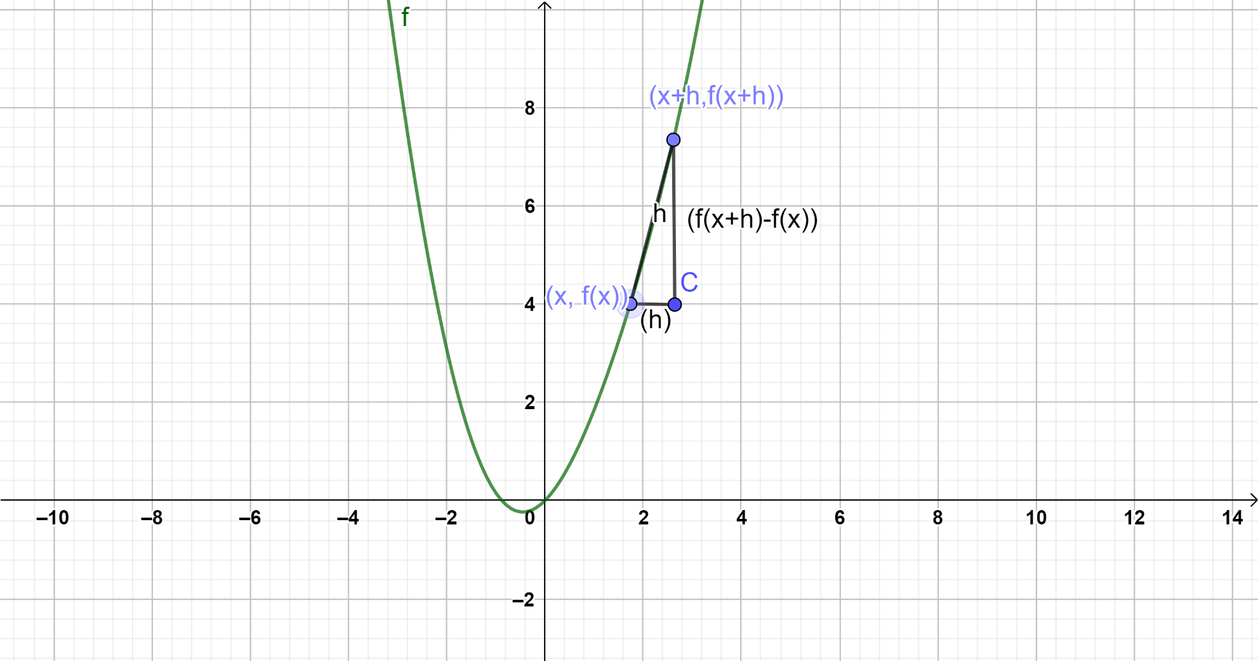
$\frac{df(x)}{dx}=\lim_{h↔0}{(\frac{f\left(x+h\right)-f\left(x\right)}{h})}$
If $f\left(x\right)=x^{2}$, for example,
$$\frac{df\left(x\right)}{dx}=\frac{{Lim }_{h→0}\left({\left(x+h\right)}^{2}-x^{2}\right)}{h}$$
$$=\frac{{Lim}_{h→0}\left(x^{2}+2xh+ h^{2}- x^{2}\right)}{h}$$
$$=\frac{{Lim}_{h→0}\left(2xh+h^{2}\right)}{h}$$
$$={Lim}_{h→0}\left(2x+h\right)=2x.$$

Find the derivatives of the following functions:
1. $f\left(x\right)= x^{3}$

2. $f\left(x\right)= x^{4}$

3. $f\left(x\right)= x^{5}$

Basic Derivative Identities:
$$\frac{df\left(x\right)}{dx}\left(Leibniz notation\right)= f^{'}\left(x\right)(Lagrange notation)$$
$$\frac{d}{dx}k=0. Derivative of a constant is zero.$$
$f\left(x\right)= x^{n}, {\frac{d}{dx}f\left(x\right)=nx^{n-1}, or f}^{'}\left(x\right)=nx^{n-1}$, e.g. f(x)=x5, f’(x) =5x4
$$f\left(x\right)=\sin\left(x\right), {\frac{d}{dx}f\left(x\right)=\cos\left(x\right), or f}^{'}\left(x\right)=\cos\left(x\right)$$
$$f\left(x\right)=\tan\left(x\right), {\frac{d}{dx}f\left(x\right)=\sec^{2}\left(x\right), or f}^{'}\left(x\right)=\sec^{2}\left(x\right)$$

$f'\left(kx\right)= k\frac{d}{dx}f\left(x\right), k is any constant.$ E.g. $\frac{d}{dx}\left(5sinx\right)=5\frac{d}{dx}\left(sinx\right)$ = 5cosx

$Product Rule: \frac{d}{dx}f\left(x\right)g\left(x\right)=f\left(x\right)\frac{d}{dx}g\left(x\right)+\frac{d}{dx}f\left(x\right)g\left(x\right)$, or ${\left(fg\right)}^{'}=f^{'}g+g^{'}f$

$$Quotient Rule: \frac{d}{dx}\left(\frac{f\left(x\right)}{g\left(x\right)}\right)=\frac{\frac{d}{dx}f\left(x\right)g\left(x\right)-f\left(x\right)\frac{d}{dx}g\left(x\right)}{g^{2}\left(x\right)} , or (\frac{f}{g})'= \frac{f^{'}g-g'f}{g^{2}}$$

$$Reciprocal Rule: \frac{d}{dx}\left(\frac{1}{f\left(x\right)}\right)= -\frac{\frac{d}{dx}f\left(x\right)}{{f\left(x\right)}^{2}}=f'/f^2 \left(taken from Quotient rule\right)$$
$$Lagrange notation {\left(\frac{1}{f}\right)}^{'}= \frac{-f'}{f^{2}}$$
$$\frac{d}{dx}sin\left(x\right)=cosx$$
$$\frac{d}{dx}cos\left(x\right)=-sinx$$
$$\frac{d}{dx}tan\left(x\right)=\sec^{2}x$$
$$\frac{d}{dx}ln\left(x\right)=\frac{1}{x}, x>0$$
$$\frac{d}{dx}sec\left(x\right)=sec\left(x\right)tan(x)$$
$$\frac{d}{dx}arcsin\left(x\right)=\frac{1}{\sqrt{1-x^{2}}}$$
$$\frac{d}{dx}arccos\left(x\right)=-\frac{1}{\sqrt{1-x^{2}}}$$
$$\frac{d}{dx}arctan\left(x\right)=\frac{1}{1+x^{2}}$$
$$\frac{d}{dx}f(x)=\frac{1}{\frac{d}{dx}f^{-1}(x)}$$
$\frac{d}{dx}a^{x}=ln(a)a^{x}$, proof is easy by taking logarithm of y = $a^{x}$ and implicit differentiation.
$$Chain Rule:f{\left(g\left(x\right)\right)}^{'}=f^{'}\left(g\left(x\right)\right)g^{'}\left(x\right), e.g. f\left(g\left(x\right)\right)=\sin\left(x^{3}\right),{\sin\left(x^{3}\right)}^{'}=f^{'}\left(\sin\left( x^{3}\right)\right)f^{'}\left(x^{3}\right)=\cos\left(x^{3}\right)\left[3x^{2}\right]=3x^{2}cos⁡(x^{3})$$
Practice Problems
- $f\left(x\right)= {\left(6x^{2}+7x\right)}^{4}$
- $g\left(t\right)= {(4t^{2}-3t+2)}^{-2}$
- $y=\sqrt[3]{1-8z}$
- $R\left(w\right)=csc⁡(7w)$
- $G\left(x\right)=2\sin\left(3x+\tan\left(x\right)\right)$
- $h\left(u\right)=\tan\left(4+10u\right)$
- $f\left(t\right)=5+e^{4t+t^{7}}$
- $g\left(x\right)=e^{1-\cos\left(x\right)}$
- $H\left(z\right)=2^{1-6z}$
- $u\left(t\right)=\tan^{-1}\left(3t-1\right)$

SI Prefixes and Symbols Used to Denote Powers of 10
Prefix | Multiple | Symbol
yotta | 10²⁴ | Y
zetta | 10²¹ | Z
exa | 10¹⁸ | E
peta | 10¹⁵ | P
tera | 10¹² | T
giga | 10⁹ | G
mega | 10⁶ | M
kilo | 10³ | k
hecto | 10² | h
deca | 10 | da
deci | 10⁻¹ | d
centi | 10⁻² | c
milli | 10⁻³ | m
micro | 10⁻⁶ | mu
nano | 10⁻⁹ | n
pico | 10⁻¹² | p
femto | 10⁻¹⁵ | f
atto | 10⁻¹⁸ | a
zepto | 10⁻²¹ | Z
yotto | 10⁻²⁴ | Y

